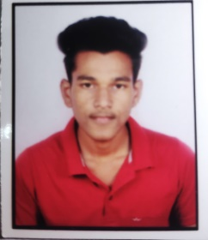**RESUME**

**MIR ZIAUDDIN**

H no.14{1),

Kaina,

Sayedpur,jajpur,

Odisha-755027

+91 86586 52588

Email id : [mirziauddin57@gmail.com](mailto:mirziauddin57@gmail.com)

**OBJECTIVE**

To work with an organization where can learn new skills and increase my abilities for the organizational goals as well as myself.

**EDUCATIONAL QUALIFICATION**

* Persuing MCA 1st year from Centurian University Management & Technology,BBSR.
* Passed out +3 B.sc from Chatalo degree Mohavidyalaya in 2022

Mark 71.90%

* Passed out 12th from CHSE in 2019

Marks 51%

* Passed out 10th from BSE in 2017

Marks 65%

**TECHINICAL SKILL**

* Basic knowledge of computer

**WORK EXPERIENCE**

* **FRESHER**

**PERSNAL DETAILS**

* Father’s Name : Mir Kalimuddin
* Date of Birth : 25-03-2002
* Nationality : Indian
* Gender : Male
* Marital Status : Single
* Religion : Muslim
* Language Known : Hindi , English ,Odia
* Skills : good communication skills

**DECLARATION**

I here by declare that every information is true and I am responsible for its authenticity.

Date ……………….

Place………………. **(MIR ZIAUDDIN)**